COP5725 Advanced Database Systems

Efficient Anomaly Monitoring Over Moving Object Trajectory Streams

Mourya Kodidela
Abstract: There is an increasing demand for efficient anomaly monitoring over trajectory streams. The data is normally collected from moving object tracing devices. There are so many applications of real time monitoring of abnormal sequential patterns like elder care, child custody, accurate mobile localization, automatic driving etc. A novel framework for monitoring anomalies over continuous trajectory streams is being introduced. There are other approaches other than distance based approaches that are available to detect and monitor anomalies but they do not detect more generalized anomalies and some of the approaches are based on labeling data, which is rather expensive. Though distance-based anomalies are more general and effective, their performances in monitoring anomalies suffer because of intensive distance computations. Key points to know are that the proposed algorithm requires little extra memory, sequential scans will have excessive time cost, R-tress type structures incur huge memory consumptions for indexing all subsequences that are taken from the trajectory. Initially a basic approach called simple pruning is introduced, it is accurate but it is very primitive ,require huge amount of time and too many computations, so, a batch monitoring based local clustering approached for better performance.
1 Introduction
Recently, trajectory mining has attracted much attention due to its wide applications, especially in context-aware computing environment. Sometimes abnormal trajectories tend to carry critical information of potential problems which require immediate attention and need be resolved at an early stage. There are many applications that require real-time monitoring of abnormal sequential patterns over streaming trajectories. Examples include elder care, child custody, accurate mobile localization, automatic driving and so on with focus on continuous monitoring distance-based anomalies from trajectory streams, where distance is used as a measure of (dis-)similarity between trajectory subsequences.
2 Motivation
The motivation comes from the fact that all of the above mentioned applications require efficient processing techniques so that the appropriate people or authorities can be informed about the abnormal behavior so that help may arrive in time. The existing procedures include online events, bursts, novelty detection over stream time. The reason for them to be inefficient in finding more general anomalies is that distribution is always changing, burst is only one kind of anomalies and the labeling of data has huge cost.
The challenge is to do high speed data processing on the incoming data stream so that the anomalies in the data stream can be detected efficiently, effectively and within limited space cost. There are methods proposed to this but they are not really that efficient. So, the present paper provides approaches through which the high speed data processing can be achieved within the limited space time.
3 Related Work
Online Novelty Detection on Temporal Sequences: The following method is used to detect anomalies on temporal sequences. For this purpose a new framework is proposed. The framework is used to build the new online anomaly detection which is concrete and, by modeling the temporal sequence using an online support vector regression algorithm. The framework provides us with a mechanism to associate an anomaly with a confidence value.
Adaptive Event Detection with Time–Varying Poisson Processes: The proposed time-varying Poisson model provides a robust and accurate framework for adaptively and autonomously learning how to separate unusual bursty events from traces of normal human activity. Time-series of count data are generated in many different contexts, such as web access logging, freeway traffic monitoring, and security logs associated with buildings. Since this data measures the aggregated behavior of individual human beings, it typically exhibits a periodicity in time on a number of scales (daily, weekly, etc.) that reflects the rhythms of the underlying human activity and makes the data appear non-homogeneous.
4 Terminology & Definitions
Trajectory Point- An m-dimensional point
Trajectory Stream- A stream of Trajectory points
W_{b} - Base window, a set of trajectory points taken for comparison and other operations.
W_{l} - left sliding window, W_{r} – right sliding window, D is the distance threshold.

Definition 1 (Distance). dist (q, c) is a function that has base window q and c as inputs and returns a nonnegative value d, which is said to be the distance from q to c. Without loss of generality, considering Euclidean distance as the distance measure in the implementations:
For base window X and Y, dist (X, Y) = √∑_{i} (X_{i} –Y_{i})² for i=1 to W_{b}

For a m-D trajectory stream, for base window X and Y,
dist (X, Y) = √∑_{i} ∑_{j} (X_{i} [j] –Y_{i}[j])² for i=1 to W_{b} , j = 1 m

Definition 2 (Neighbor). Given a base window B = {s_{j}, s_{j}+1,...,s_{j} + w_{b} −1} which is a candidate currently to be judged whether it is an anomaly, a trajectory stream S ={s₁, s₂,... ,s_{h}} where h ≥ w_{b}, and distance threshold d, for any subsequence S_{i} ={s_{i}, s_{i+1},..., s_{i+wb−1}} of S, if distance(B, S_{i}) < d, we say that Si is a neighbor of B in S.

Definition 3: (Trajectory Stream Anomaly). For a base window B in S, the number n₁ is the B’s neighbors in its left sliding window L, and the number n₂ is the B’s neighbors in its right sliding window R, then B is a trajectory stream anomaly if n₁ + n₂ < k.

Definition 4 (Trajectory Stream Anomaly Detection Problem). On trajectory stream S, at every time tick t, upon the arrival of s_{t}, we check whether the base window B ending at s_{t−wr} is a trajectory stream anomaly.
5 Techniques used
Simple Pruning:
Simple pruning is one of the basic techniques for distance based anomaly detection. A base window is selected and is tested with other window or base windows in both left and right sliding windows. If distance is less than D it's a neighbor. 'D' is the distance threshold. Consider N1 to be number of neighbors in left sliding window and N2 to be number of neighbors in right sliding window. 'K' is the minimum neighbor count threshold. If N1+N2>=k then it's not an anomaly otherwise it's an anomaly.

Algorithm Online Local Clustering:

Input: latest base window Bnew, latest time tick t
Global variables: distance threshold τ, temporal constraint m_{b}, Boolean pivotfound, current pivot pcurrent, current radius r, current left bin L. (Initially pivot found ← FALSE; pcurrent←NULL, r←0; L ← φ.)

1: if pivotfound = FALSE then
2: (Comments: accumulate points in the left bin)
3: if the distance dist_{i} between Bnew and any base window Bi ending in the current left bin > τ or
current cluster size = m_{b} then
4: the current left bin minus time tick t − 1 is the final left bin
5: set time tick t − 1 as the pivot_pcurrent
6: pivotfound ← TRUE
7: else
8: time tick t is added to the current left bin L
9: update r to be the greatest dist_{i}
10: end if
11: end if
12: if pivotfound then
13: (Comments: accumulate points in the right bin)
14: find distance dist between Bnew and the base window ending at pcurrent
15: if dist > τ or current cluster size is mb then
16: time ticks in {pcurrent, ..., t − 1} ∪ L forms a local cluster
17: set current left bin L to {t}, r ← 0,
18: pcurrent ← NULL, pivotfound ← FALSE
19: else
20: if dist > r then
21: r ← dist
22: end if
23: end if
24: end if

In simple words, the simple pruning approach was too time consuming and require too many computation, hence the local clustering algorithm. In this approach, a base window is selected as a pivot, a distance threshold 'τ' is selected, the distance between the selected pivot and the other windows of same length with in the sliding window are calculated. If the calculated distance is less than the distance threshold then it can be considered as a neighbor. These neighbors along with the pivot form a cluster. The cluster has a maximum size limit and if the number of neighbors is greater than this value then the pivot is not eligible to form a cluster.
The threshold is called maximum cluster size represented by 'm_{b}'. The search for neighbors starts from left sliding window and goes towards right sliding window. The pivot is then taken as the center of the cluster and the distance between the pivot and farthest neighbor is taken as the radius of the cluster. All the rest of the neighbors are scattered within that radius. After the cluster is formed, it is then compared with the other clusters. The following test cases help in simplification and reduce the number of comparisons and finally decrease the time taken to evaluate.
Let p represent a pivot and it is the center of one cluster and similarly q represents center of another cluster. C, Q clusters and window is a set a trajectory points of n-dimensions, same size as the base window. The five cases for anomaly detection in trajectory stream are depicted in figure 1.

Case 1: If pq - r1 - r2 > D, there are no neighbors.
The above left hand side of the above condition represents straight line distance between the two cluster circumferences and if it is greater than the threshold value D the they are not considered neighbors and there is no need to compare each window of trajectory points within the cluster with the corresponding window in another cluster, this greatly decreases the number of computations.
Case 2: If pq + r1 + r2 < D, all base windows of c1 are neighbors to all base windows of c2 and vice versa.
Similarly, if the sum of distances from one end of one cluster to other end of another cluster is less than the threshold value D then all the windows in one cluster are neighbors of another and vice versa.
Case 3: If dis (bw , q) + r2 < D, the base window bw is a neighbor to all the base windows of q.
If first and the second cases fail, the third case is checked, if it is satisfied then it means that some of the windows in one cluster are neighbors of some windows of other cluster.
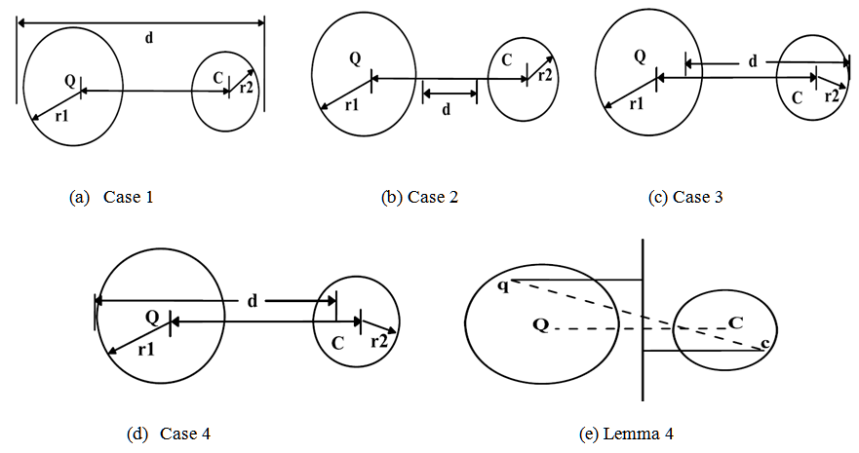
Figure 1: Local Cluster Relationships

Case 4: If dis (bw , p) + r1 < D, the base window bw is a neighbor to all the base windows of p.
This case is basically same as case3.
Case 5: If all the cases fail, then check for each base window with all other base windows.

Piece wise VP Tree Rescheduling:
A vantage-point tree (or VP tree) is that segregates data in by choosing a position in the space (the "vantage point") and partitioning the data points into two parts. Those points that are nearer to the vantage point than a threshold, and those points those are not. By recursively applying this procedure to partition the data into smaller and smaller sets, a tree data structure is created where neighbors in the tree are likely to be neighbors in the space. The basic idea is to build index for pivots along current sliding window and then reschedule the cluster join order so as to approach the best search order. VP-tree occupies much less memory than R-tree, because R-tree has to store bounding boxes in its nodes, but VP tree’s nodes only need to store pivots. Actually, any tree index structures that do not store high dimensional vectors in their nodes could be employed here. Note that once a VP-tree is built, the only function of it is to answer range queries targeting at the pivots which are indexed by it, and will never be updated all its life time. When a batch search (range query) is issued, first look for the query cluster’s spatially nearby clusters through the VP-tree list. However, the trick here is that the query cluster is not joined with selected candidate clusters immediately when they are found, for the reason that in worst case, the join cost for two local cluster pair of size m will require m2 distance computations.

5 Results
The Simple Pruning, Batch Monitoring with Online Local Clustering and Join Rescheduling with Piecewise VP Tree indexing techniques are evaluated in terms of the effectiveness and efficiency for anomaly detection using real world datasets (movement, ge, altitude).
Table I
Parameter Description

Parameter | Notation | Description
Base Window Length | W_{b} | 128 & 256
Neighbor Threshold | K | Varied between 8 to 15
Diameter | D | 0.1 of maximum diameter of dataset
Trajectory Stream Size | T_{s} | 815122
Left Sliding Window Size | W_{l} | movement – 165122, ge – 55832,  altitude – 244159
Right Sliding Window Size | W_{r} | movement – 165122, ge – 55832,  altitude - 244159
Piece Window Size | PWS | 480
VP Tree Leaf Size | LS | 10

Table II
Experimental Evaluation on movement, ge and altitude datasets

W_{b} | K | Execution Time  (seconds) |  |  | No. of Computations  (M)
W_{b} | K | JR | BM | SP | JR | BM | SP
128 | movement.dat
128 | 8 | 69 | 123 | 910 | 23 | 73 | 783
128 | 10 | 89 | 149 | 976 | 48 | 154 | 993
128 | 12 | 68 | 123 | 1198 | 76 | 248 | 1290
128 | 14 | 79 | 129 | 1293 | 106 | 346 | 1417
128 | 15 | 105 | 162 | 1508 | 137 | 446 | 1424
128 | ge.dat
128 | 8 | 200 | 232 | 1291 | 20 | 76 | 757
128 | altitude.dat
128 | 8 | 32 | 74 | 1840 | 71 | 174 | 3598
128 | 10 | 33 | 73 | 1878 | 70 | 206 | 3611
256 | movement.dat
256 | 8 | 355 | 1250 | 4300 | 40 | 206 | 2155
256 | 10 | 472 | 1238 | 5600 | 49 | 244 | 2599
256 | ge.dat
256 | 8 | 776 | 961 | 4919 | 50 | 210 | 1334
 | altitude.dat
 | 8 | 121 | 189 | 4824 | 37 | 73 | 4468

The ‘movement’ dataset contains 12 days' trajectories of one person on his way between home and office in a car, where the data are collected from a GPS sensor carried by the person. It contains 4 outlier regions as follows, each of which is a seldom event in some day's trajectory of the 12 days'. The ‘ge’ dataset consists of the stock price series from year 1928 to year 2007 of GE Company, obtained from finance@Yahoo. In the dataset, each data point is the open price of each working day in the historical record. The ‘altitude’ dataset contains the normalized altitude of 3-day full trajectories collected by outdoor GPS sensors in the Chinese University of Hong Kong; the length of each trajectory is 218,448.
An Intel(R) Core (TM) i5-4210U CPU @ 1.70GHz with 8GB RAM is used to conduct all the experiments. In the implementation, the trajectory stream is simulated in the main memory. First, the trajectory dataset is loaded into the main memory, and the parameters are initialized. A new trajectory point arrives at every time tick. As and when new trajectory points arrive in the trajectory stream, anomaly detection is triggered. For temporally overlapping anomalies, only the first discovered one which can represent the whole problematic region is reported. The parameter setup considered in the process of anomaly detection is described in Table I.
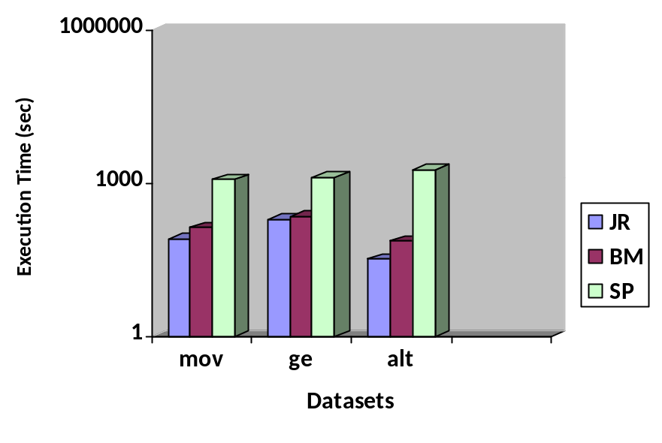
Figure 2: Execution Time, W_{b} = 128

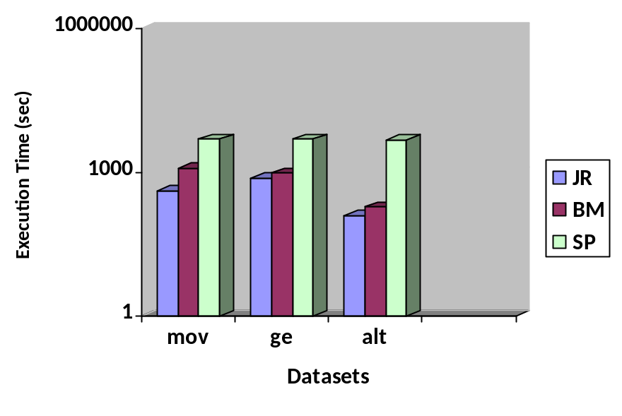
Figure 3: Execution Time, W_{b} = 256
The experimental results of anomaly detection on movement, ge and altitude datasets are shown in Table II. The results are tabulated for comparing the efficiency of the techniques Join Rescheduling (JR), Batch Monitoring (BM) and Simple Pruning. The parameters base window length W_{b} and neighbor threshold K. are varied and the execution time and the number of distance computations of the algorithms are recorded.

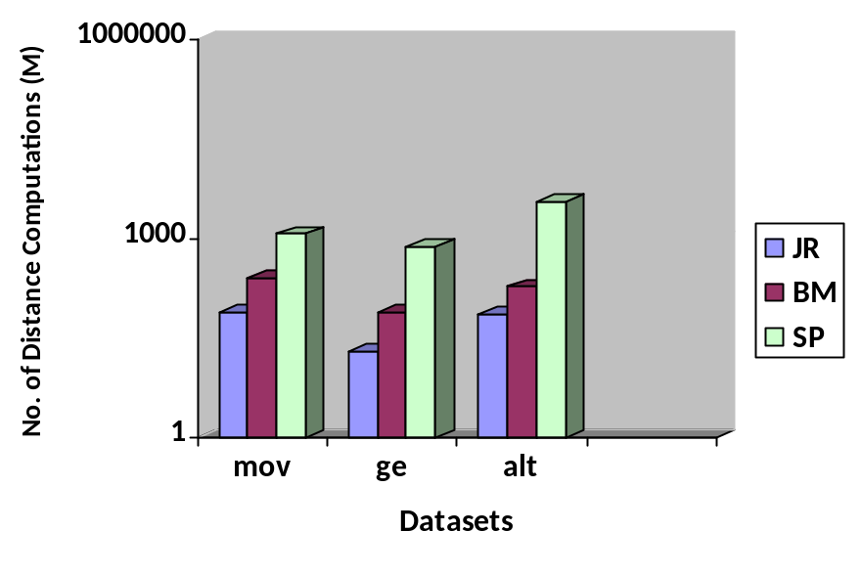
Figure 4: No. of Distance Computations, W_{b} = 128

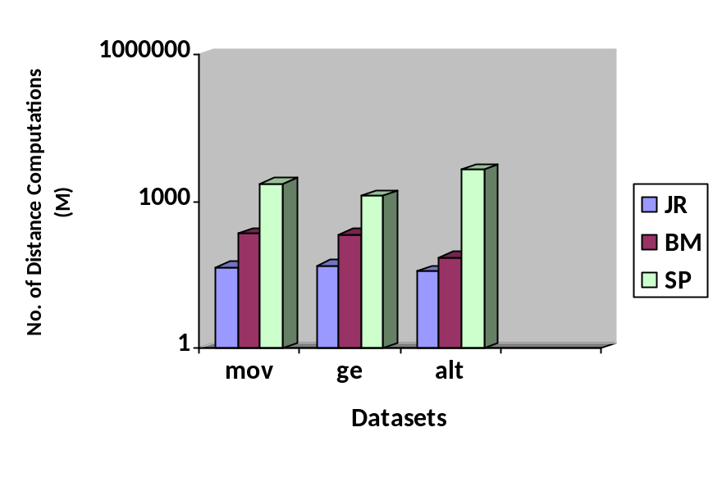
Figure 5: No. of Distance Computations, W_{b} = 256

The average performance of the three techniques over the considered datasets is computed for comparing the performance in terms of execution time and number of distance computations. From the comparative charts in figures 2 to 5, it is seen clearly that Join Rescheduling with Piecewise VP Tree Indexing gets an order of magnitude improvement over Simple Pruning in terms of execution time. In terms of number of computations, there is an improvement up to 45 times. With Simple Pruning, the average processing time per data point arrival is 3.889 milliseconds, while with Join Rescheduling with Piecewise VP Tree Indexing it is only 0.332 milliseconds.
6 Conclusion
The importance of anomaly detection in trajectory data streams and its applications are studied. The Simple Pruning, Batch Monitoring with Online Local Clustering and Join Rescheduling with Piecewise VP Tree indexing techniques are analyzed. The techniques are evaluated in terms of the effectiveness and efficiency for anomaly detection using real world datasets.

The Code, Datasets and documentation are available in the following link:
https://github.com/surfstream/Distance-based-Anomaly-detection

References:

[1] Yingyi Bu, Lei Chen, Ada Wai-Chee Fu, Dawei Liu, Efficient Anomaly Monitoring Over
Moving Object Trajectory Streams, KDD '09 Proceedings of the 15th ACM SIGKDD
international conference on Knowledge discovery and data mining, Pages 159-168, 2009.

[2] Alexander T. Ihler, Jon Hutchins, and Padhraic Smyth. Adaptive event detection with time-
varying poisson processes. In KDD, pages 207–216, 2006.

[3] Junshui Ma and Simon Perkins. Online novelty detection on temporal sequences. In KDD, pages
613–618, 2003.

[4] Michail Vlachos, Christopher Meek, Zografoula Vagena, and Dimitrios Gunopulos. Identifying
similarities, periodicities and bursts for online search queries. In SIGMOD Conference, pages
131–142,2004.

[5] Edwin M. Knorr and Raymond T. Ng. Algorithms for mining distance-based outliers in large
datasets. In VLDB, pages 392–403, 1998.

